**SDA Notes Unit4**

**Part1**

**SAMPLING**

SAMPLING - the method of gathering information about a population by taking a representative of the population called sample.

For example, if a drug manufacturer would like to research the adverse side effects of a drug on the country’s population, it is almost impossible to conduct a research study that involves everyone. In this case, the researcher decides a sample of people from each demographic and then researches them, giving him/her indicative feedback on the drug’s behavior.

Types of sampling: sampling methods

1. Probability sampling: [Probability sampling](https://www.questionpro.com/blog/probability-sampling/) is a sampling technique where a researcher sets a selection of a few criteria and chooses members of a population randomly. All the members have an equal opportunity to be a part of the sample with this selection parameter.
2. Non-probability sampling: In [non-probability](https://www.questionpro.com/blog/non-probability-sampling/) sampling, the researcher chooses members for research at random. This sampling method is not a fixed or predefined selection process. This makes it difficult for all elements of a population to have equal opportunities to be included in a sample.

**SAMPLING METHODS**

1. Simple Random Sampling

2. Systematic Random Sampling

3. Stratified Sampling

4. Cluster Sampling

**SIMPLE RANDOM SAMPLING**

- involves selecting a sample size n from a population of size N so that all elements of the population have equal chances of being part of the sample.

• Lotteries • tables of random numbers • automatic random number generator

Example

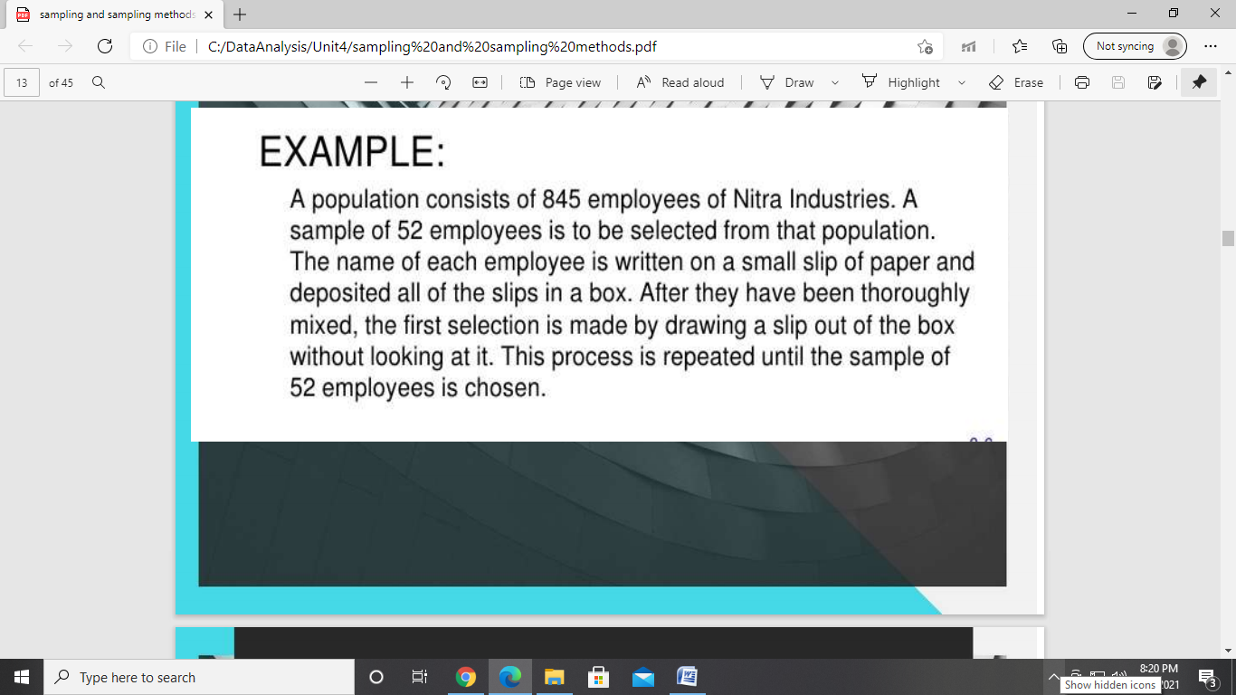

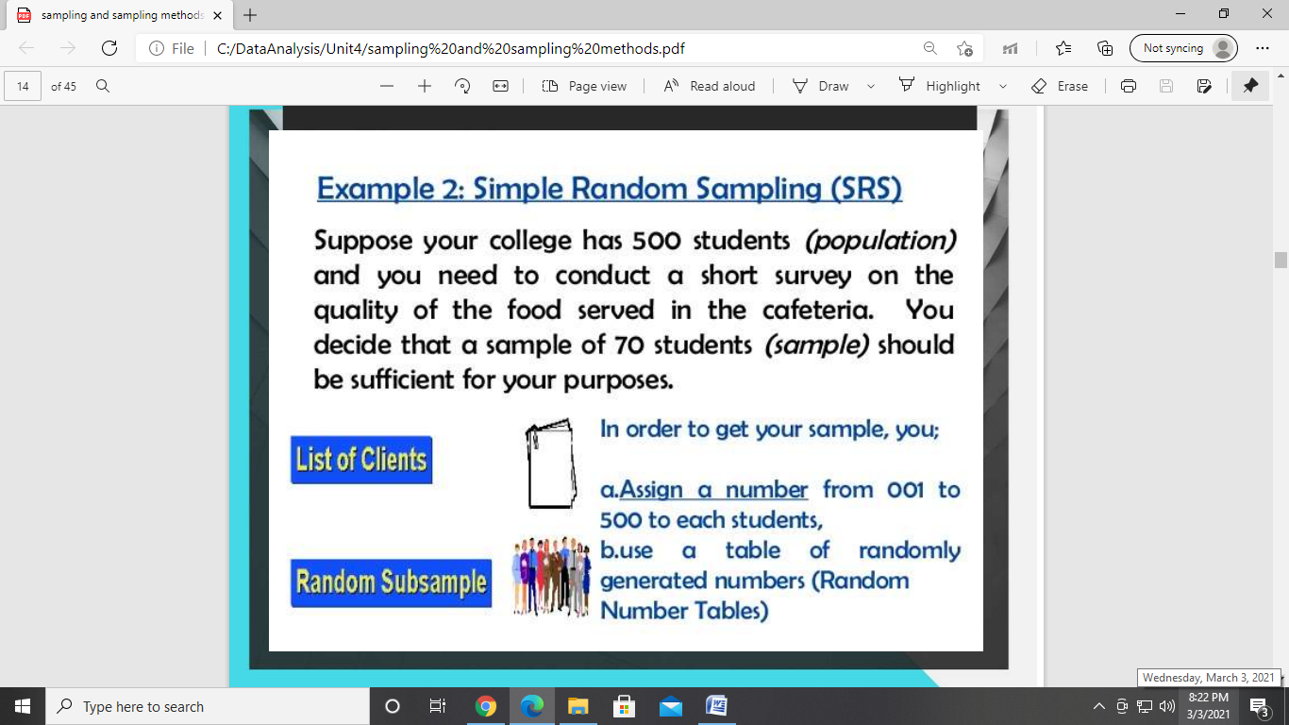

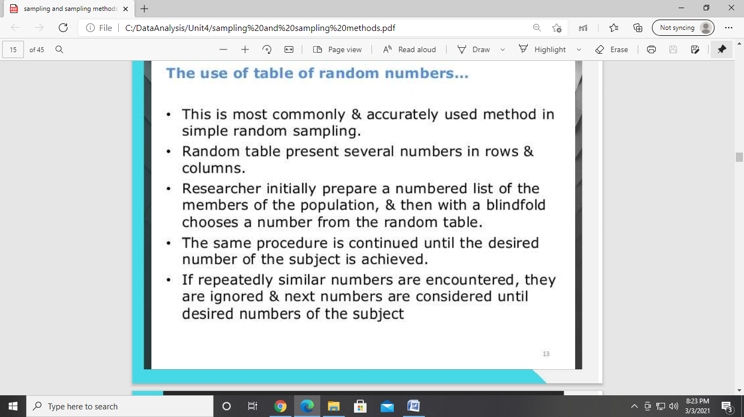

**SYSTEMATIC RANDOM SAMPLING**

- involves using a random start to determine the first element of the sample and the selection of the rest of the sample is done systematically, i.e., every kth interval, where k = N/n.

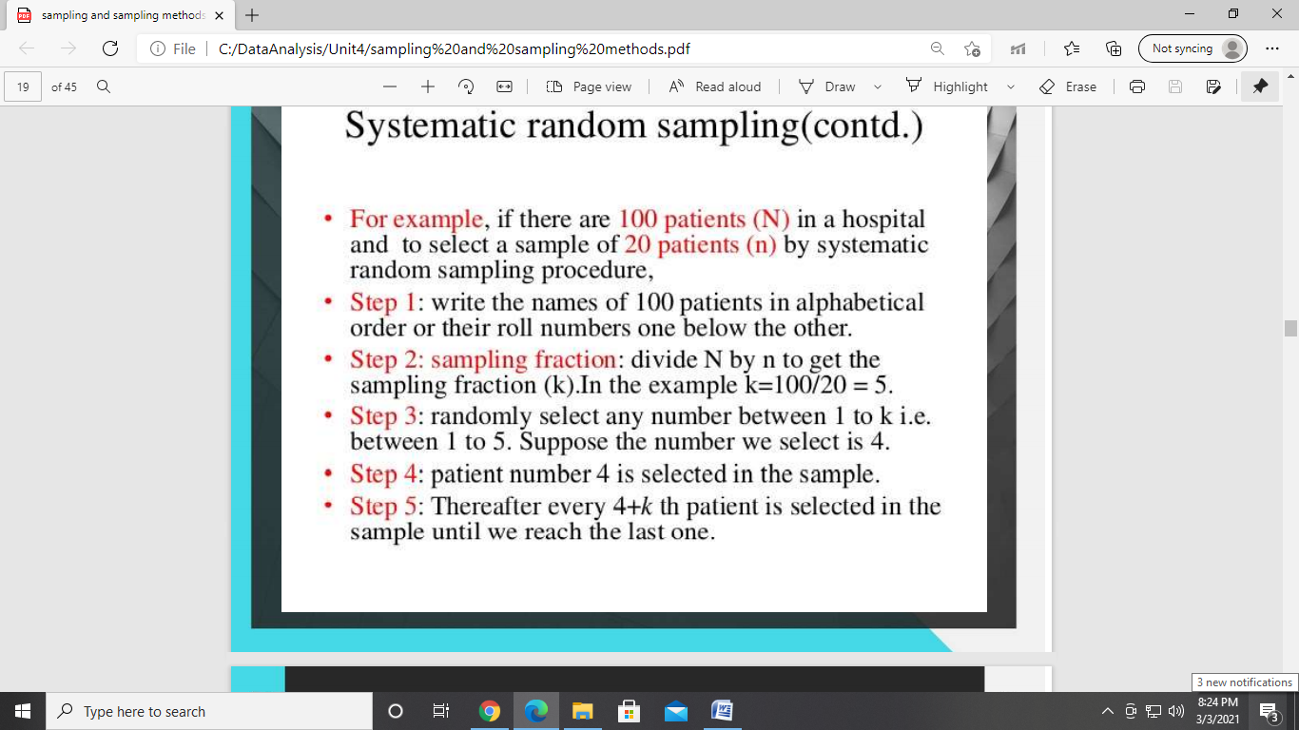

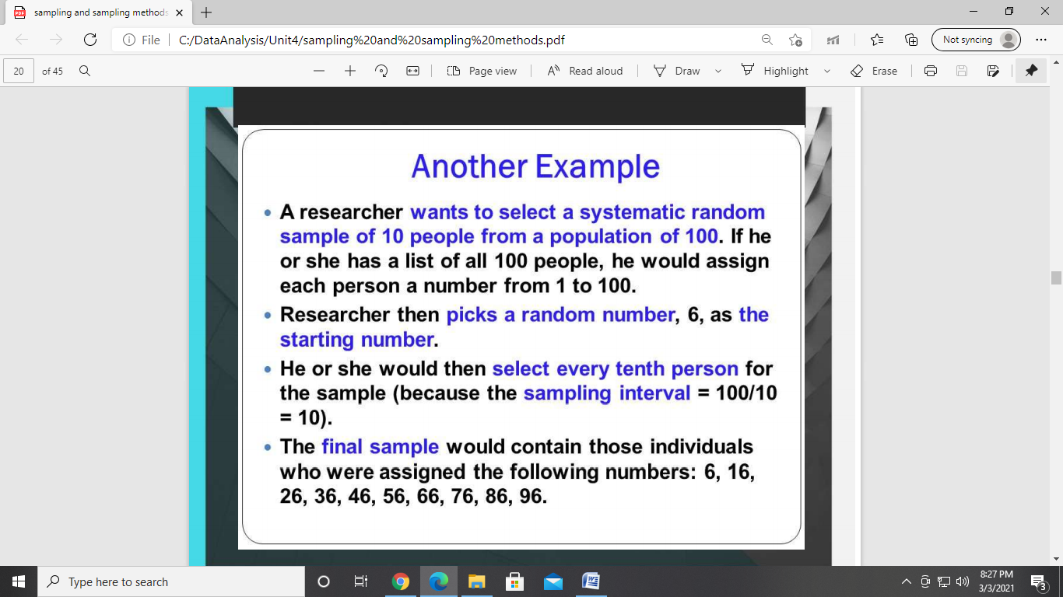

**STRATIFIED SAMPLING**

- involves dividing the population into groups called STRATA according to some chosen classification category such as age, gender, geographic location, and so on. Subsample from each stratum are selected by simple random sampling

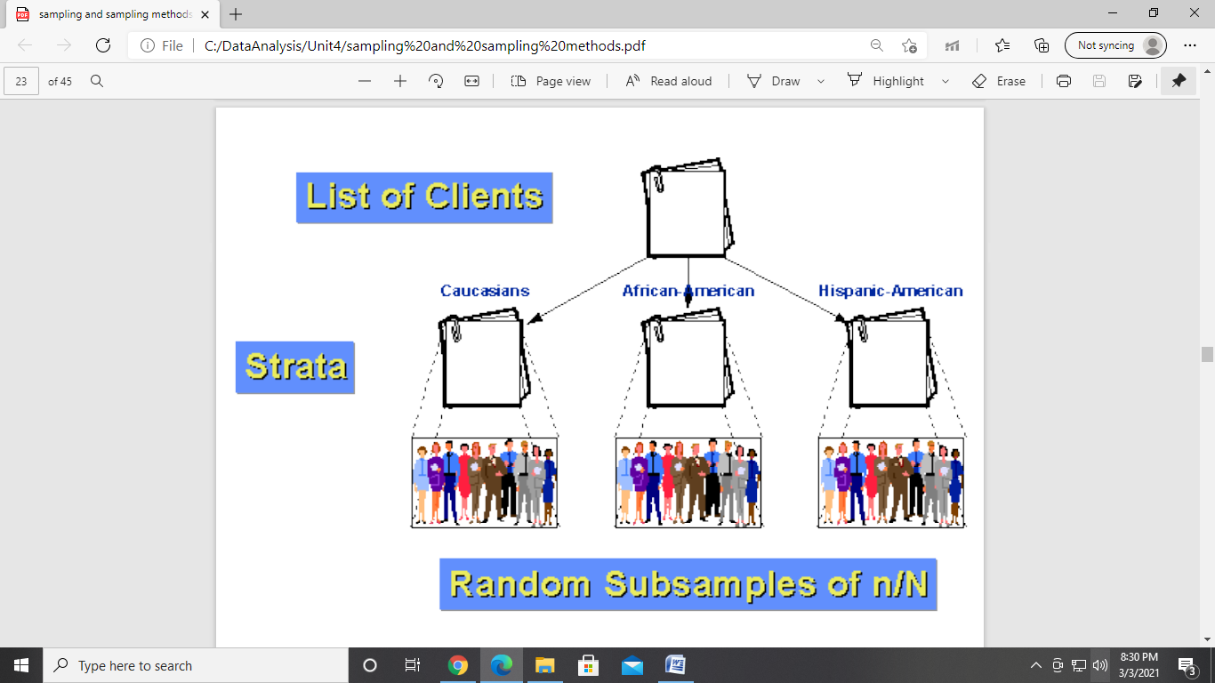

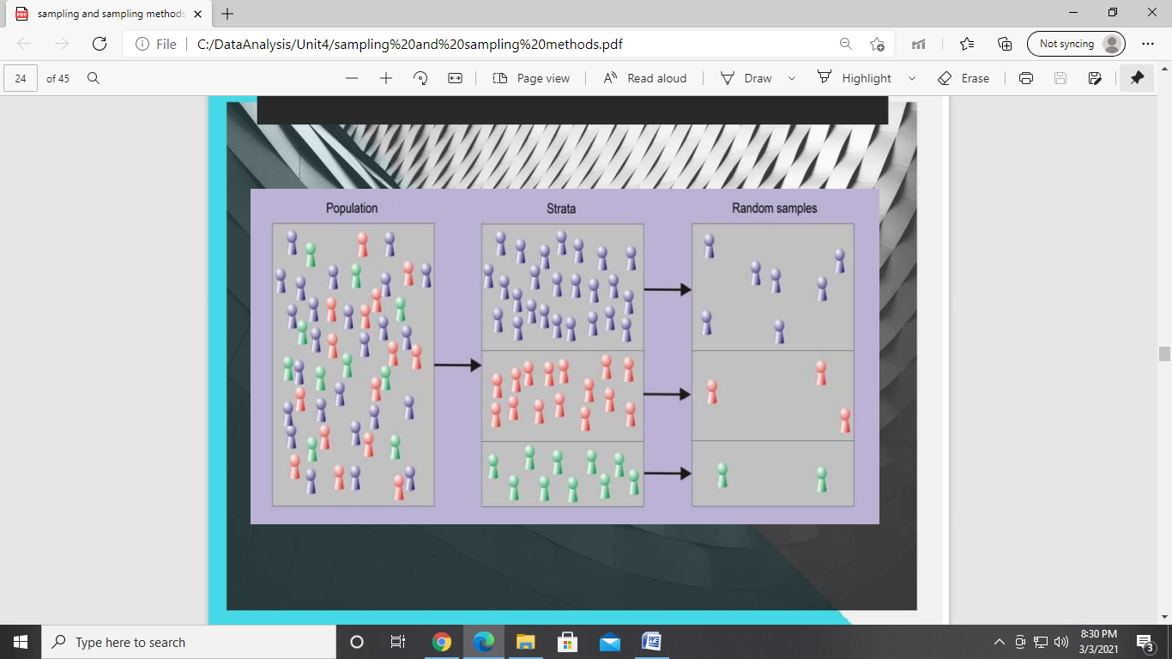

**CLUSTER SAMPLING**

- the elements of the population are divided into groups called CLUSTERS. Clusters are naturally occurring like barangays, cities, or municipalities. Samples are obtained from each cluster by SRS.

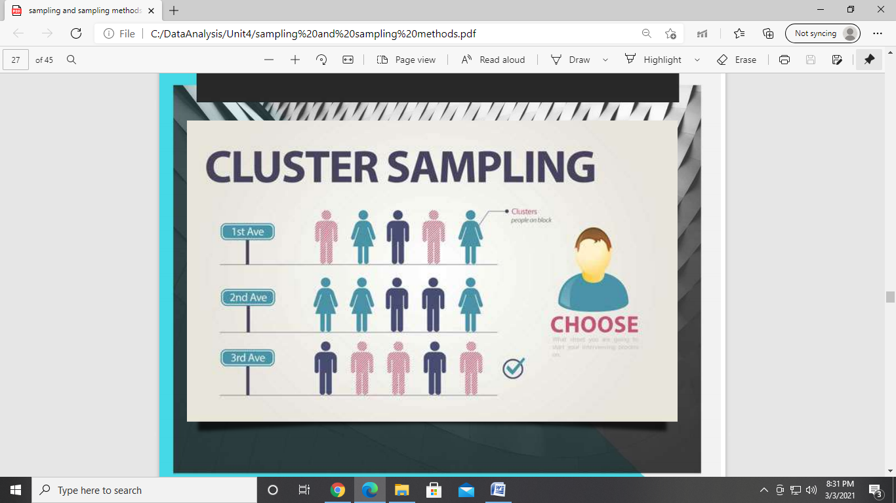

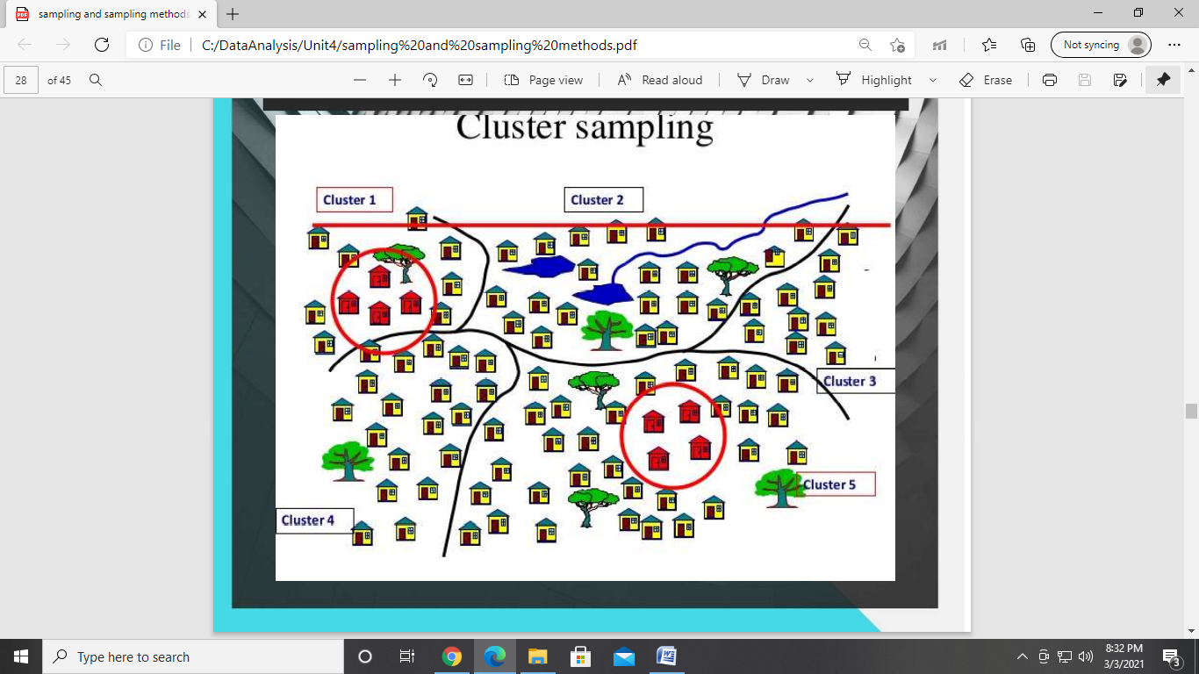

**SLOVIN’S FORMULA** -

* Used to calculate the sample size n given the population size N and a margin of error e.
* Slovin's formula is used when nothing about the behavior of a population is known at all.

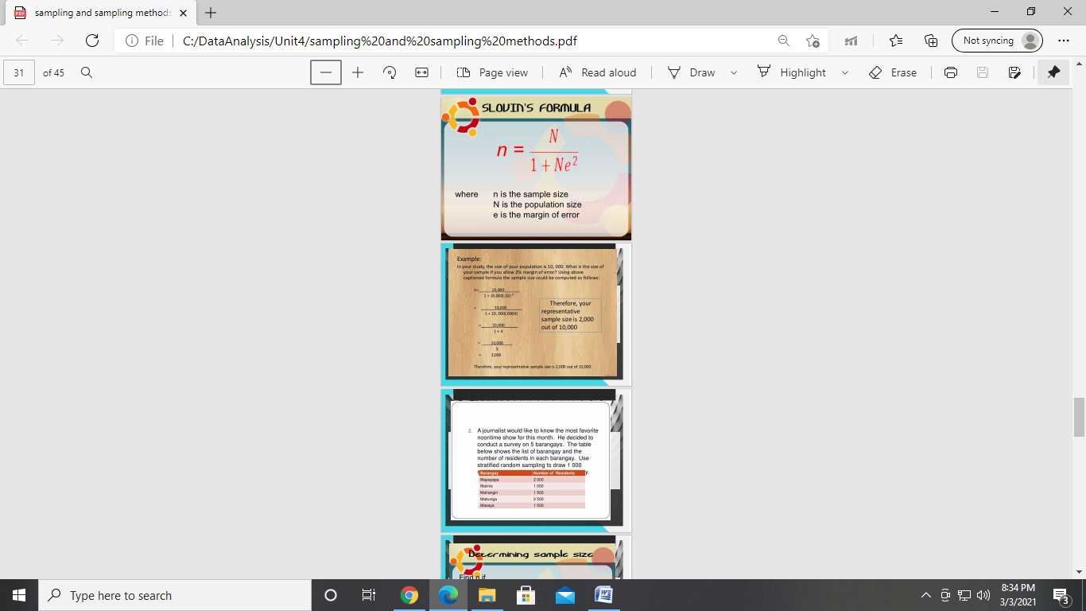

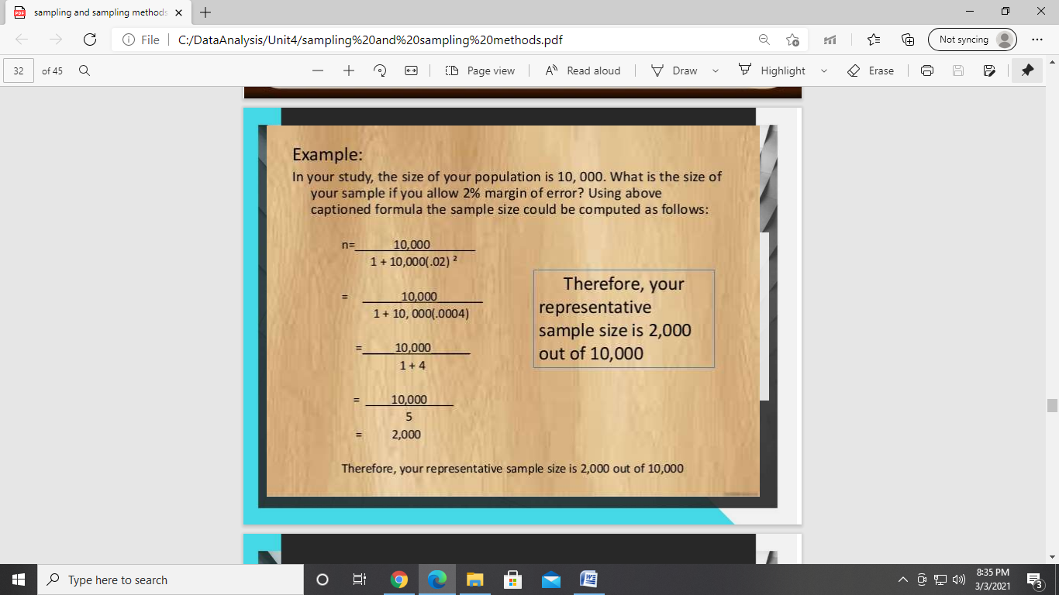

**Sampling Distribution**

* The sampling distribution of a statistics is the probability distribution of that statistics.
* The sampling distribution of a statistic is the distribution of the statistic for all possible samples from the same population of a given size.
* Knowledge of the sampling distribution can be very useful in making inferences about the overall population.

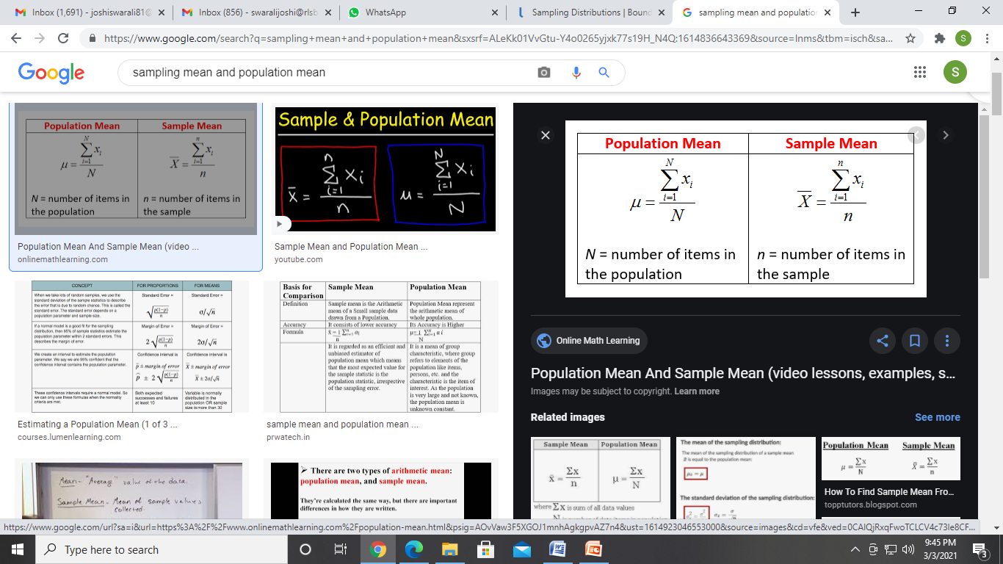

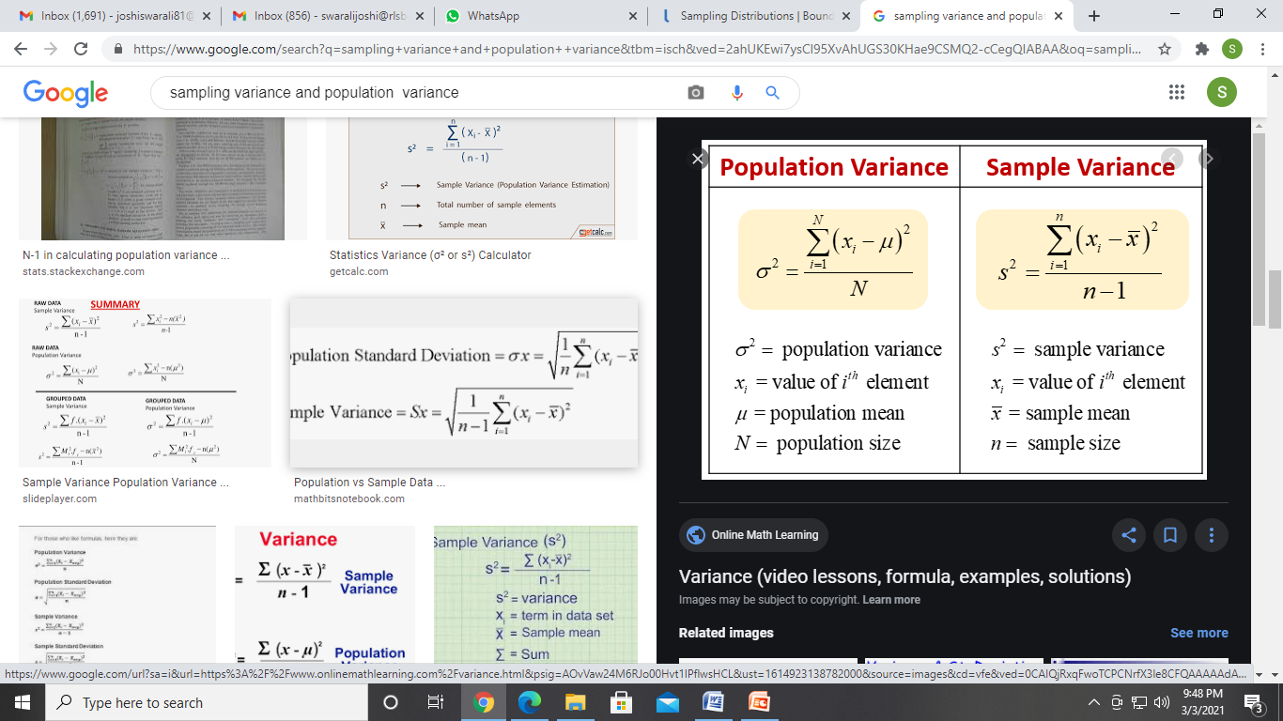

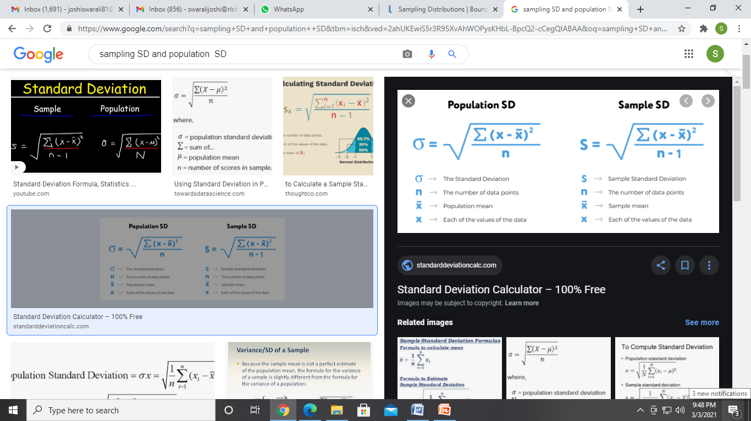

**Example on Sampling Distribution**

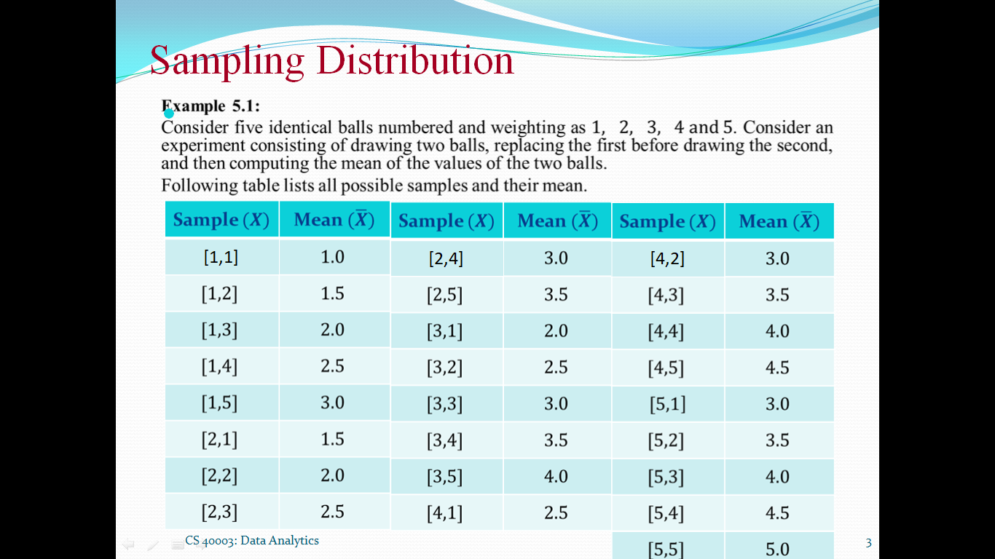

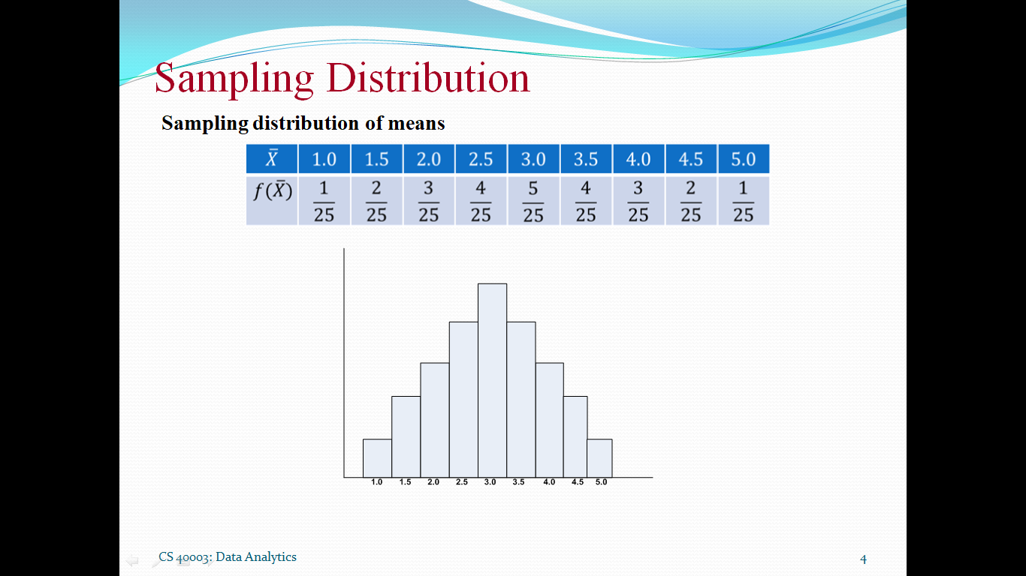

**Central Limit Theorem**

* The central limit theorem in [statistics](https://statisticsbyjim.com/glossary/statistics/) states that, given a sufficiently large [sample](https://statisticsbyjim.com/glossary/sample/) size, the sampling distribution of the [mean](https://statisticsbyjim.com/glossary/mean/) for a variable will approximate a normal distribution regardless of that variable’s distribution in the [population](https://statisticsbyjim.com/glossary/population/).
* The central limit theorem applies to almost all types of probability distributions, but there are exceptions. For example, the population must have a finite variance.

**Examples on Central Limit Theorem**

A population is normally distributed with mean 20 standard deviation 6.Samples of size 9 are drawn from the population.What are the equivalent Z score of the following sample means

a) 22 b) 25

Solution:

μ=20 , σ=6

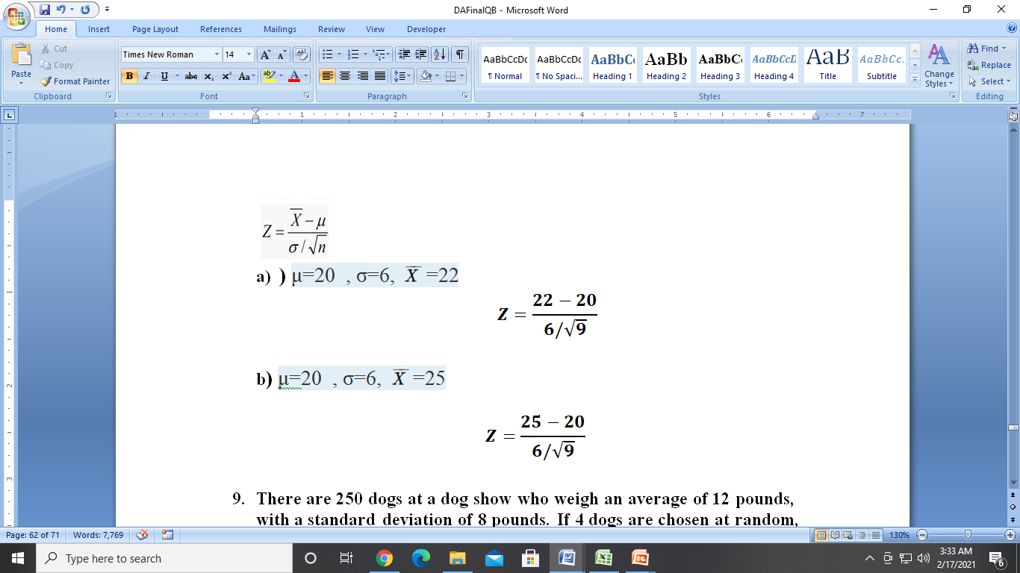

* **Examples on Central Limit Theorem**

There are 250 dogs at a dog show who weigh an average of 12 pounds, with a [standard deviation](https://www.statisticshowto.datasciencecentral.com/probability-and-statistics/standard-deviation/) of 8 pounds. If 4 dogs are chosen at random, what is the [probability](https://www.statisticshowto.datasciencecentral.com/probability-and-statistics/probability-main-index/) they have an average weight of greater than 8 pounds and less than 25 pounds?

Solution:

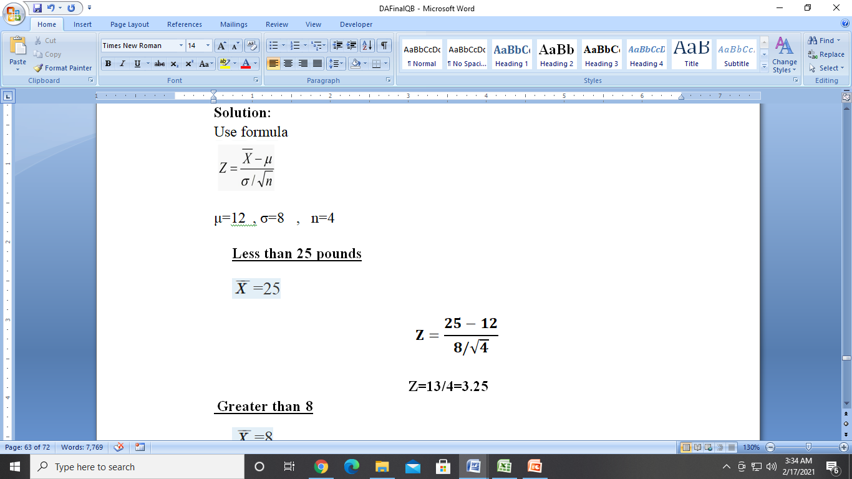

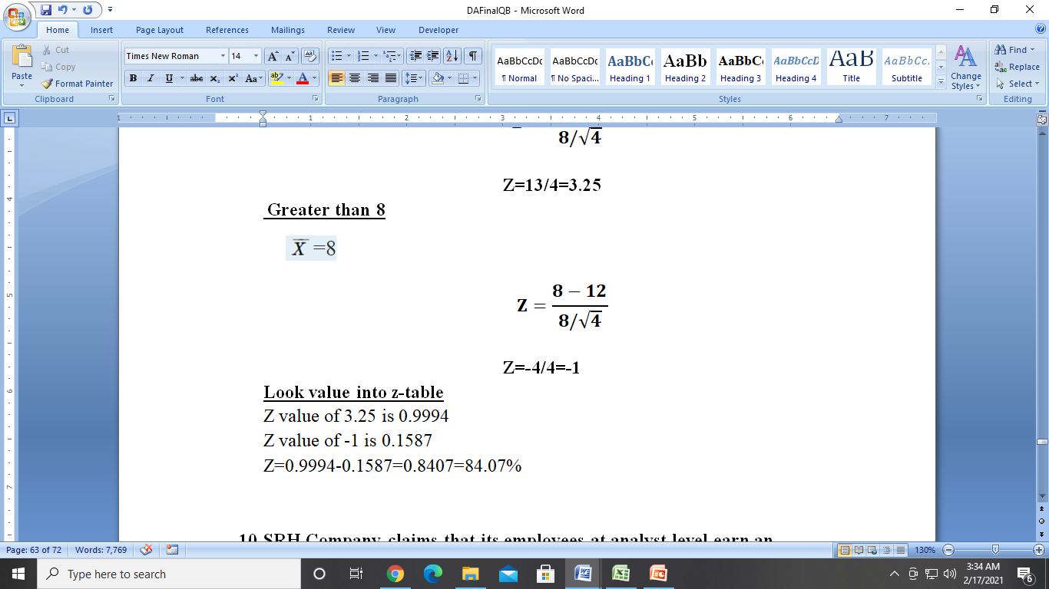

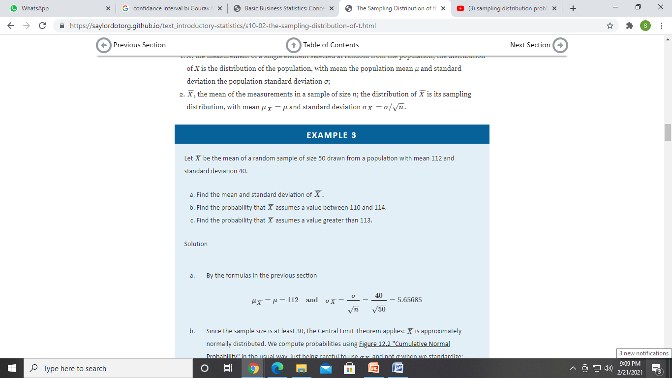

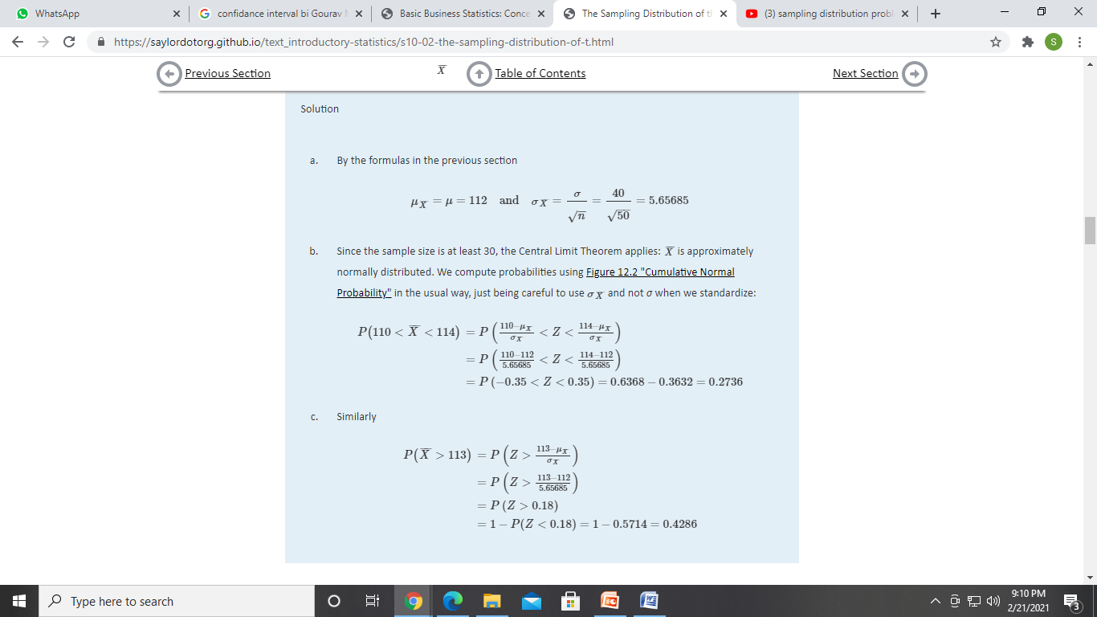

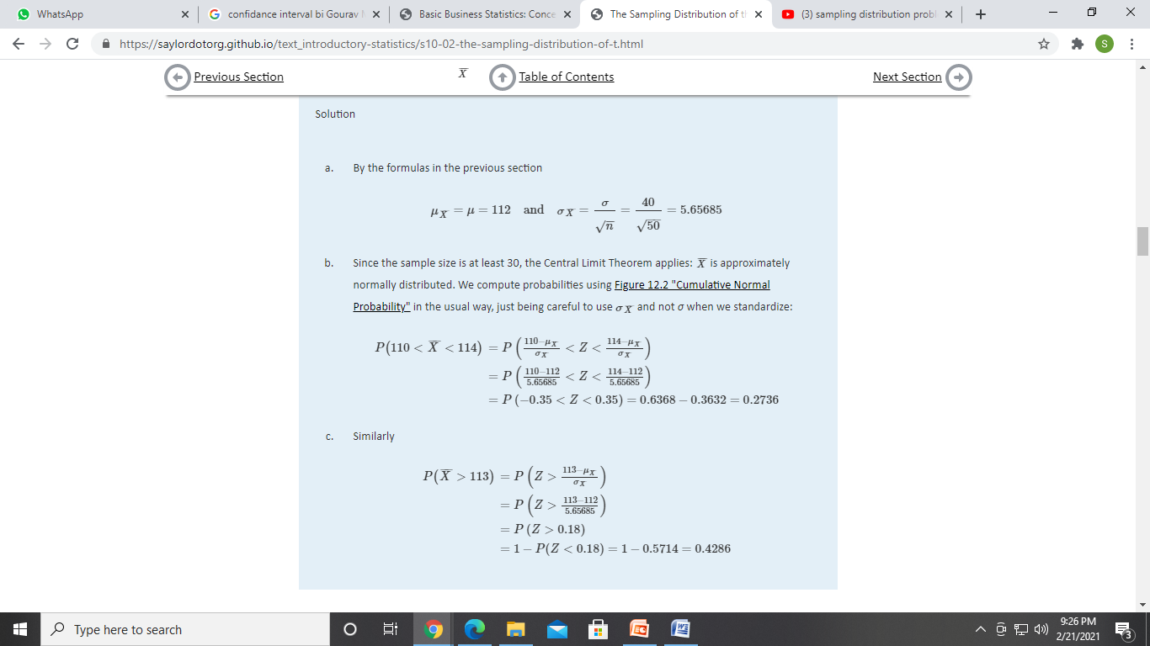

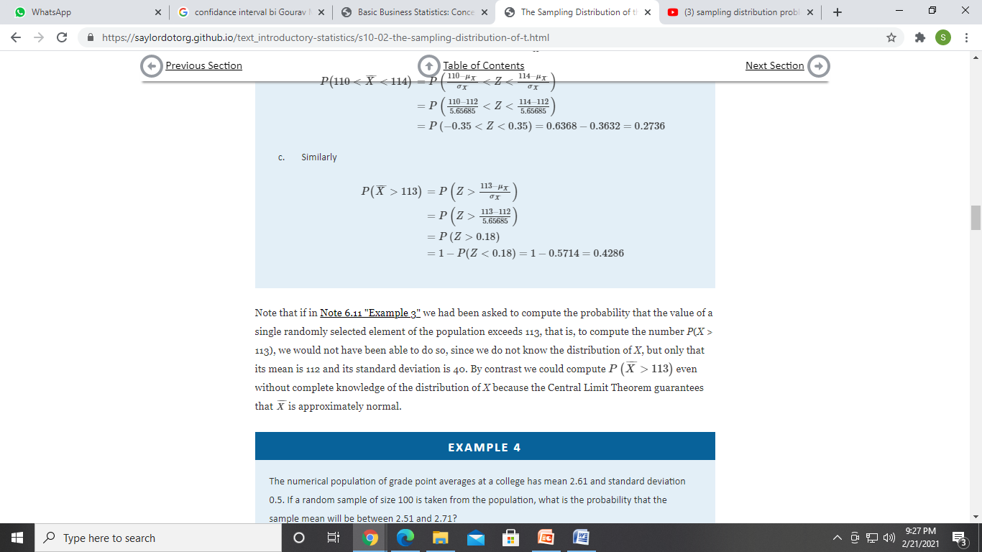

**Confidence Interval**

* This is a range of numbers constructed around point estimate. The confidence interval is constructed such that the probability that the interval includes population parameters is known.
* Confidence intervals measure the degree of uncertainty or certainty in a [sampling](https://www.investopedia.com/terms/s/sampling.asp) method.
* Confidence interval formula when population parameters are known

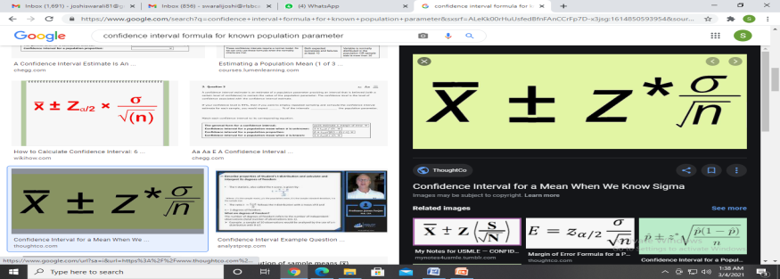

Confidence Interval Values

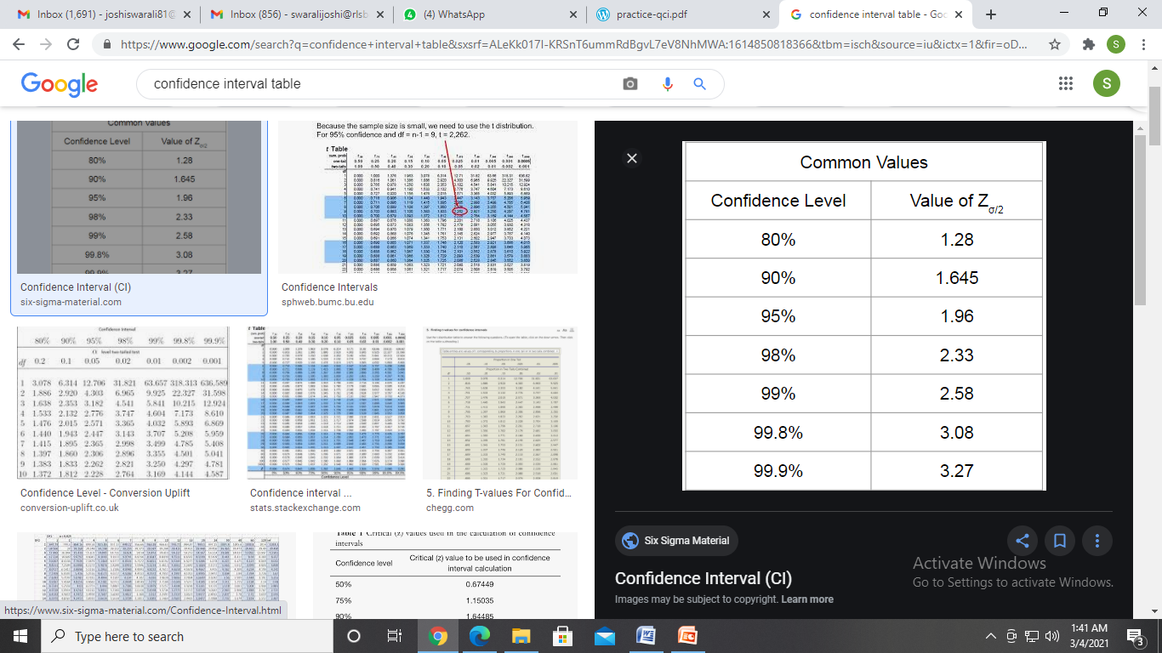

**Problems on Confidence Interval**

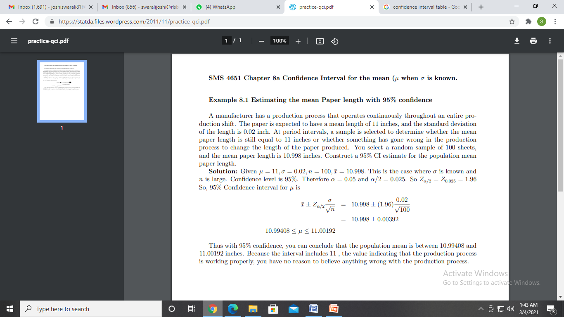

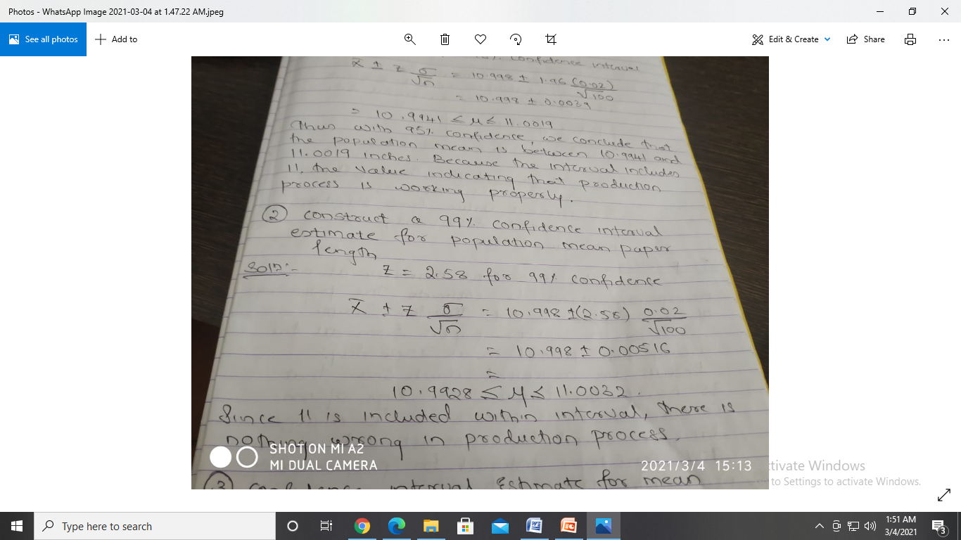

**Confidence Interval estimate for mean (σ Unknown)**

**T-Distribution**

* Also Called as Student t-distribution.
* Sample size is small(n<30)
* Population standard deviation is Unknown
* The population from which sample is taken is normally distributed

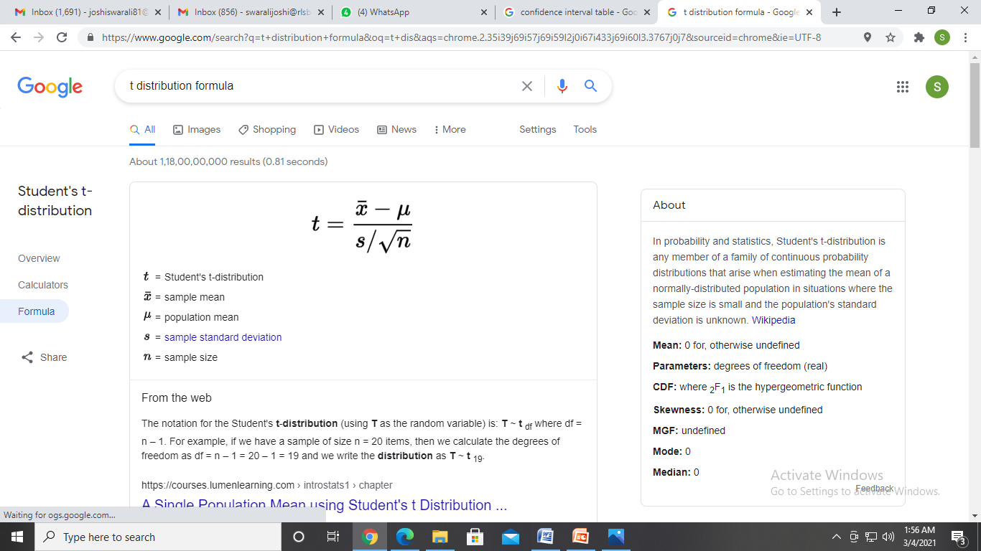

**Examples on t-distribution**

**SRH Company claims that its employees at the analyst level earn an average of $500 per hour. A sample of 30 employees at the analyst level is selected, and their average earnings per hour were $450, with a sample deviation of $30. And assuming their claim to be true, calculate the t -distribution value, which shall be used to find the probability for t – distribution.**

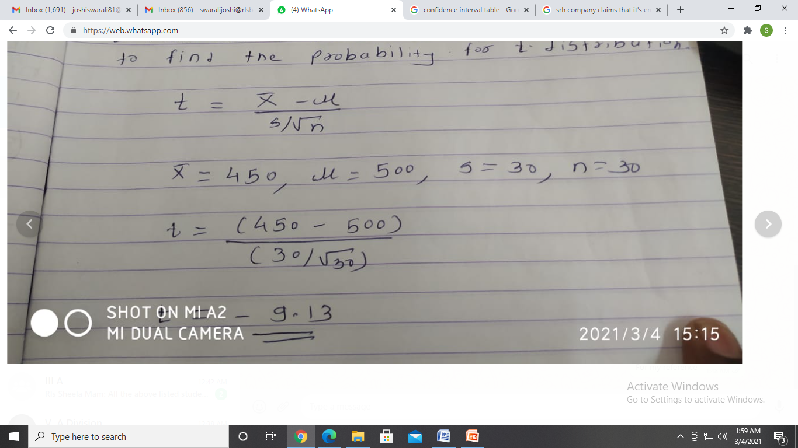

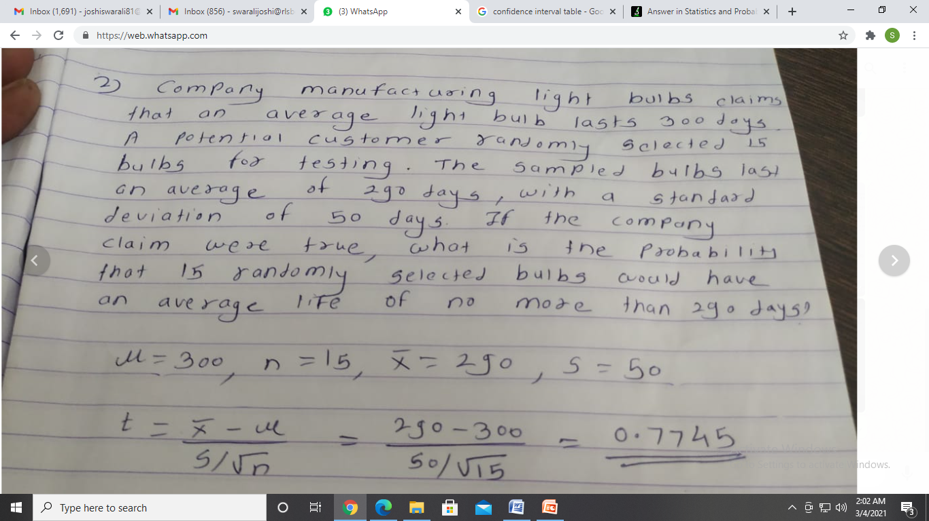

**Confidence Interval estimate for proportion**

* You can find the [**confidence interval**](https://www.dummies.com/education/math/statistics/how-to-calculate-a-confidence-interval-for-a-population-mean-when-you-know-its-standard-deviation/) (CI) for a population proportion to show the statistical probability that a characteristic is likely to occur within the population.
* When a characteristic being measured is categorical — for example, opinion on an issue (support, oppose, or are neutral), gender, political party, or type of behavior (do/don’t wear a seatbelt while driving) — most people want to estimate the proportion (or percentage) of people in the population that fall into a certain category of interest. For example, consider the percentage of people in favor of a four-day work week, the percentage of Republicans who voted in the last election, or the proportion of drivers who don’t wear seat belts. In each of these cases, the object is to estimate a population proportion, *p,* using a sample proportion,

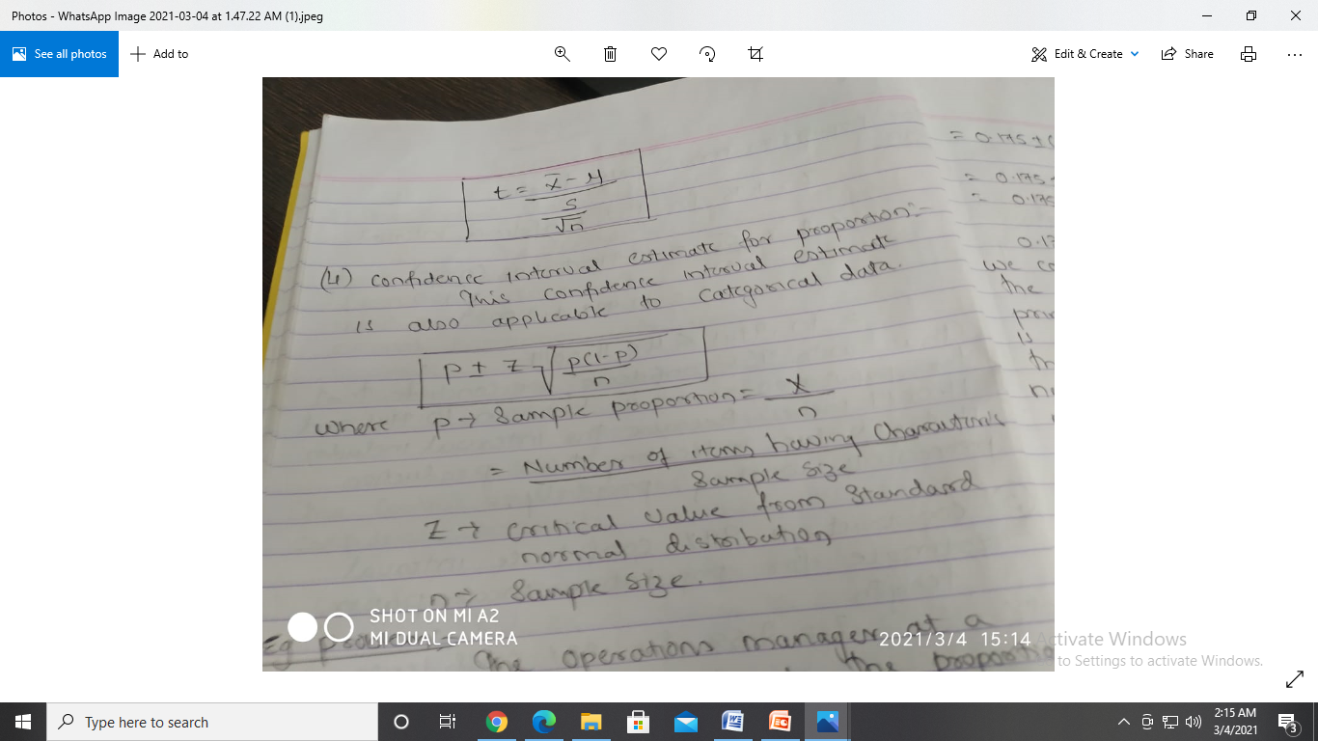

**Example**

